Taxonomic Antonyms

What is Taxonomic Antonyms
# Source: AI Source: Provided by: [Data Path: Persons Table -> ID Column: 1, Name_En Column: Motasem Essam] -> From: [Chatgpt (GPT-4-turbo)] on [7/30/2025]
Taxonomic antonyms are words that belong to the same semantic category or class but represent mutually exclusive types or subcategories within it. They are not direct opposites in meaning, but are considered "opposite" in classification.

📊 Overview Table
# Source: AI Source: Provided by: [Data Path: Persons Table -> ID Column: 1, Name_En Column: Motasem Essam] -> From: [Chatgpt (GPT-4-turbo)] on [7/30/2025]
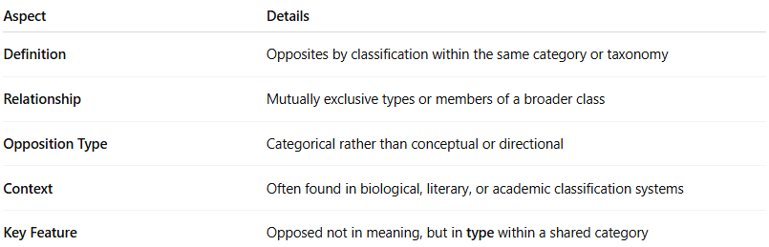
Aspect | Details
Definition | Opposites by classification within the same category or taxonomy
Relationship | Mutually exclusive types or members of a broader class
Opposition Type | Categorical rather than conceptual or directional
Context | Often found in biological, literary, or academic classification systems
Key Feature | Opposed not in meaning, but in type within a shared category

🧠 Examples of Taxonomic Antonyms
# Source: AI Source: Provided by: [Data Path: Persons Table -> ID Column: 1, Name_En Column: Motasem Essam] -> From: [Chatgpt (GPT-4-turbo)] on [7/30/2025]
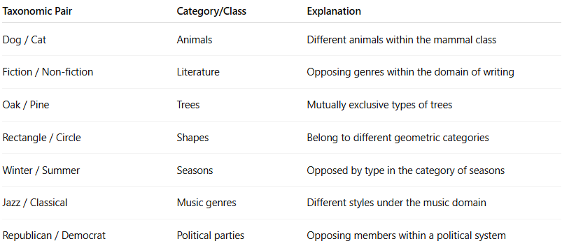
Taxonomic Pair | Category/Class | Explanation
Dog / Cat | Animals | Different animals within the mammal class
Fiction / Non-fiction | Literature | Opposing genres within the domain of writing
Oak / Pine | Trees | Mutually exclusive types of trees
Rectangle / Circle | Shapes | Belong to different geometric categories
Winter / Summer | Seasons | Opposed by type in the category of seasons
Jazz / Classical | Music genres | Different styles under the music domain
Republican / Democrat | Political parties | Opposing members within a political system

✅ Key Characteristics:
# Source: AI Source: Provided by: [Data Path: Persons Table -> ID Column: 1, Name_En Column: Motasem Essam] -> From: [Chatgpt (GPT-4-turbo)] on [7/30/2025]
- Not true antonyms in core meaning, but in classification
- They do not form scales or involve reversal
- Often depend on contextual grouping

